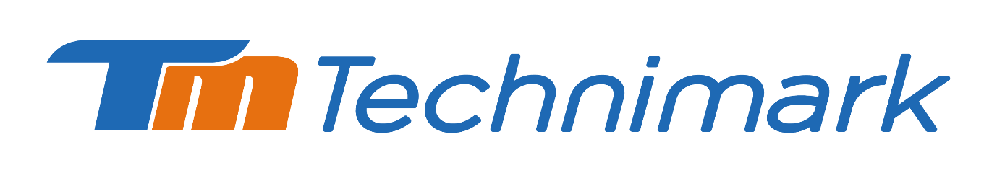





**About Technimark**

Technimark is a global manufacturing solutions provider for the healthcare, consumer packaging and specialty industrial markets. Technimark specializes in precision injection moulding, value-added assembly, and contract manufacturing. Technimark provides clients with customized, end-to-end solutions based on technology and innovation that improve quality, reduce risk, lower costs, and speed products to market. With facilities in the United States, Mexico, Germany, Ireland, the United Kingdom, and China, Technimark delivers high-quality products worldwide. As part of Technimark’s commitment to sustainable and responsible business practices, the company has embedded the Ten Principles of the United Nations Global Compact into strategies and operations, and committed to respecting human and labour rights, safeguarding the environment, and working against corruption in all its forms. For more information, visit [technimark.com](https://www.technimark.com/).

The Longford site invested €26million in 2022 to extend the facility to 100,000ft².

We have three Class-8 cleanroom manufacturing areas, as well as a controlled environment and White room manufacturing. The site is certified to ISO13485 & ISO14001 and employs 145 people and focuses on Medical Device & Healthcare manufacturing for their global Medical device and Pharma customer base. The new expansion that was added in 2022, will also include Technimark’s first European Innovation Centre. When complete, the centre will incorporate office space to house designers and engineers as well as a complete production lab to perform prototype manufacturing.